**OT LAB ASSIGNMENT 2-3**

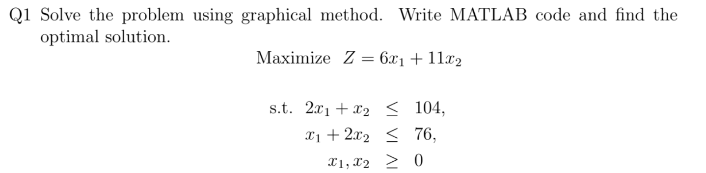

Code:

%% QUESTION 1: Graphical method to solve

% Max Z= 6x1+11x2

% 2x1+x2<=104

% x1+2x2<=76

% x2>=0

% x1>=0

clc

clear all

format short

%INPUT PARAMETERS

c=[6,11]; %cost objective function

A=[2,1;1,2;0,1;1,0];

B=[104;76;0;0];

n=size(A,1);

x1=0:0.01:max(B);

for i=1:n-2 %we take n-2 since we are also taking x1=0 and x2=0 as they have no significance in our graph

y(i,:)=(B(i)-A(i,1)*x1)/A(i,2);

end

%DRAWING THE LINES

for i=1:n-2

y(i,:)=max(0,y(i,:));

plot(x1,y(i,:),'linewidth',4)

hold on

end

hold on

%FINDING THE POINT OF INTERSECTION

pt=[0;0];

for i=1:size(A,1)

A1=A(i,:);

B1=B(i,:);

for j=i+1:size(A,1)

A2=A(j,:);

B2=B(j,:);

A3=[A1;A2];

B3=[B1;B2];

%X3=inv(A3)*B3

X3=A3\B3;

if(X3>=0)%since the number of chairs can never be negative

pt= [pt X3];

end

end

end

X=pt';

X=unique(X,'rows')%solution

hold on

% KEEP ONLY FEASIBLE POINTS

x1=X(:,1);

x2=X(:,2);

for i=1:n-2

ind=find(A(i,:)*X'>B(i));

X(ind,:)=[];

end

% EVALUATE THE OBJECTIVE FUNCTION VALUE

obj_val=c*X';

[value, ind]=max(obj_val);

value;

X(ind,:);

Optimal=[X(ind,:) value]

Optimal_Coordinates = X(ind,:)

Optimal_Value= value

% Shaded feasible region

x=X(:,1);

y=X(:,2);

scatter(X(:,1),X(:,2),'*')

hold on

k=convhull(x,y);%the shaded region where a and y is satisfied

fill(x(k),y(k),'m')

% setting the axes

xlim([0 max(x)+1])

ylim([0 max(y)+1])

xlabel('x-axis')

ylabel('y-axis')

title('Feasible region of the linear programming problem')

legend('2x_1+x_2\leq104','x_1+2x_2\leq76','x_1,x_2\geq0')

Output:

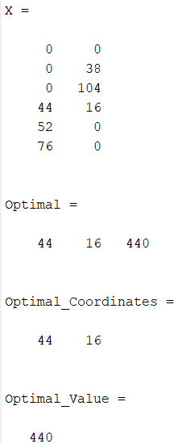

Graph:

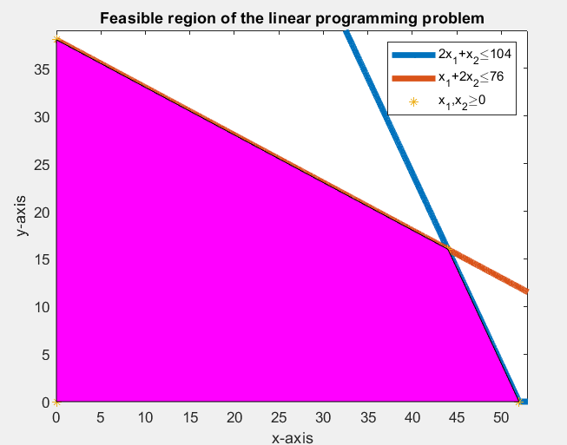

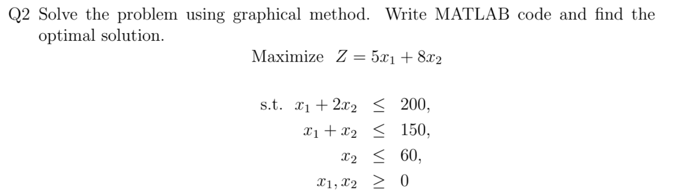

Code:

%% QUESTION 2: Graphical method to solve

% Max Z= 5x1+8x2

% 2x1+x2<=200

% x1+2x2<=150

% x2<=60

% x1,x2>=0

clc

clear all

format short

%INPUT PARAMETERS

c=[5,8]; %cost objective function

A=[1,2;1,1;0,1;1,0;0,1];

B=[200;150;60;0;0];

n=size(A,1);

x1=0:0.01:max(B);

for i=1:n-2 %we take n-2 since we are also taking x1=0 and x2=0 as they have no significance in our graph

y(i,:)=(B(i)-A(i,1)*x1)/A(i,2);

end

%DRAWING THE LINES

for i=1:n-2

y(i,:)=max(0,y(i,:));

plot(x1,y(i,:),'linewidth',4)

hold on

end

hold on

%FINDING THE POINT OF INTERSECTION

pt=[0;0];

for i=1:size(A,1)

A1=A(i,:);

B1=B(i,:);

for j=i+1:size(A,1)

A2=A(j,:);

B2=B(j,:);

A3=[A1;A2];

B3=[B1;B2];

%X3=inv(A3)*B3

X3=A3\B3;

if(X3>=0)%since the number of chairs can never be negative

pt= [pt X3];

end

end

end

X=pt';

X=unique(X,'rows')%solution

hold on

% KEEP ONLY FEASIBLE POINTS

x1=X(:,1);

x2=X(:,2);

for i=1:n-2

ind=find(A(i,:)*X'>B(i));

X(ind,:)=[];

end

% EVALUATE THE OBJECTIVE FUNCTION VALUE

obj_val=c*X';

[value, ind]=max(obj_val);

value;

X(ind,:);

Optimal=[X(ind,:) value]

Optimal_Coordinates=X(ind, :)

Optimal_Value= value

% Shaded feasible region

x=X(:,1);

y=X(:,2);

scatter(X(:,1),X(:,2),'*')

hold on

k=convhull(x,y);%the shaded region where a and y is satisfied

fill(x(k),y(k),'m')

% setting the axes

xlim([0 max(x)+1])

ylim([0 max(y)+1])

xlabel('x-axis')

ylabel('y-axis')

title('Feasible region of the linear programming problem')

legend('x_1+2x_2\leq200','x_1+x_2\leq150','x_2\leq60', 'x_1,x_2\geq0')

Output:

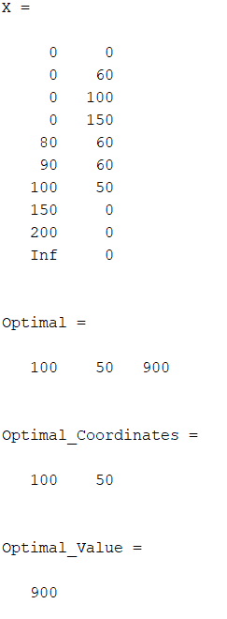

Graph:

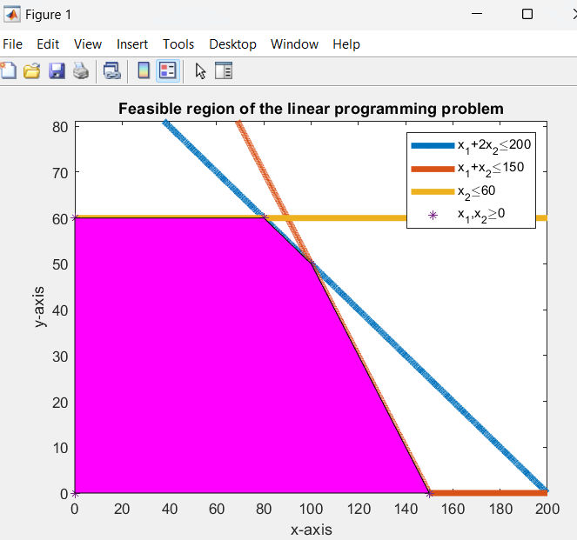

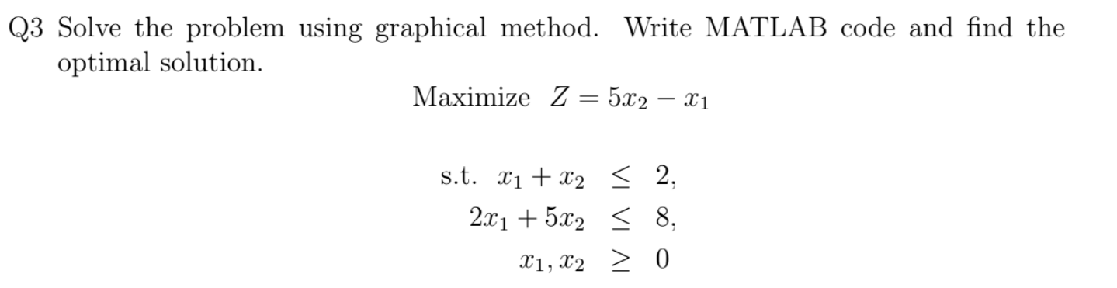

Code:

%% QUESTION 3: Graphical method to solve

% Max Z= 5x1-x2

% x1+x2<=2

% 2x1+5x2<=8

% x2>=0

% x1>=0

clc

clear all

format short

%INPUT PARAMETERS

c=[5,-1]; %cost objective function

A=[1,1;2,5;1,0;0,1];

B=[2;8;0;0];

n=size(A,1);

x1=0:0.01:max(B);

for i=1:n-2 %we take n-2 since we are also taking x1=0 and x2=0 as they have no significance in our graph

y(i,:)=(B(i)-A(i,1)*x1)/A(i,2);

end

%DRAWING THE LINES

for i=1:n-2

y(i,:)=max(0,y(i,:));

plot(x1,y(i,:),'linewidth',4)

hold on

end

hold on

%FINDING THE POINT OF INTERSECTION

pt=[0;0];

for i=1:size(A,1)

A1=A(i,:);

B1=B(i,:);

for j=i+1:size(A,1)

A2=A(j,:);

B2=B(j,:);

A3=[A1;A2];

B3=[B1;B2];

%X3=inv(A3)*B3

X3=A3\B3;

if(X3>=0)%since the number of chairs can never be negative

pt= [pt X3];

end

end

end

X=pt';

X=unique(X,'rows')%solution

hold on

% KEEP ONLY FEASIBLE POINTS

x1=X(:,1);

x2=X(:,2);

for i=1:n-2

ind=find(A(i,:)*X'>B(i));

X(ind,:)=[];

end

% EVALUATE THE OBJECTIVE FUNCTION VALUE

obj_val=c*X';

[value, ind]=max(obj_val);

value;

X(ind,:);

Optimal=[X(ind,:) value]

Optimal_Coordinates=X(ind,:)

Optimal_Value= value

% Shaded feasible region

x=X(:,1);

y=X(:,2);

scatter(X(:,1),X(:,2),'*')

hold on

k=convhull(x,y);%the shaded region where a and y is satisfied

fill(x(k),y(k),'m')

% setting the axes

xlim([0 max(x)+1])

ylim([0 max(y)+1])

xlabel('x-axis')

ylabel('y-axis')

title('Feasible region of the linear programming problem')

legend('x_1+x_2\leq2','2x_1+5x_2\leq8', 'x_1,x_2\geq0')

Output:

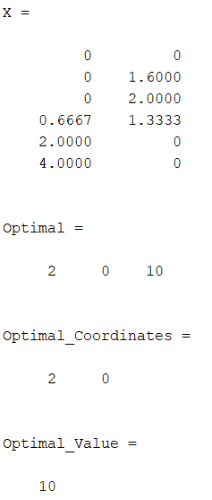

Graph:

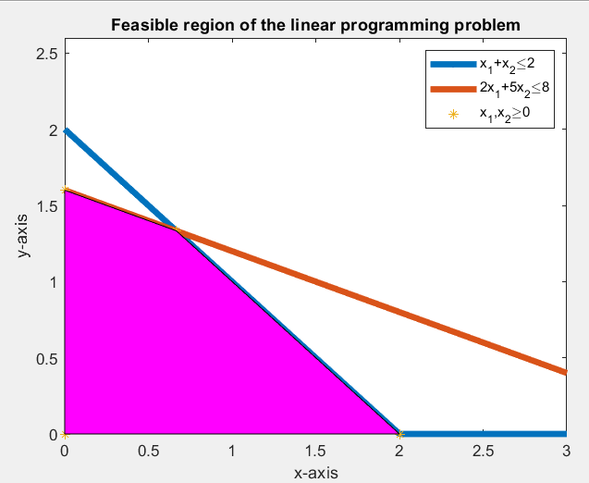

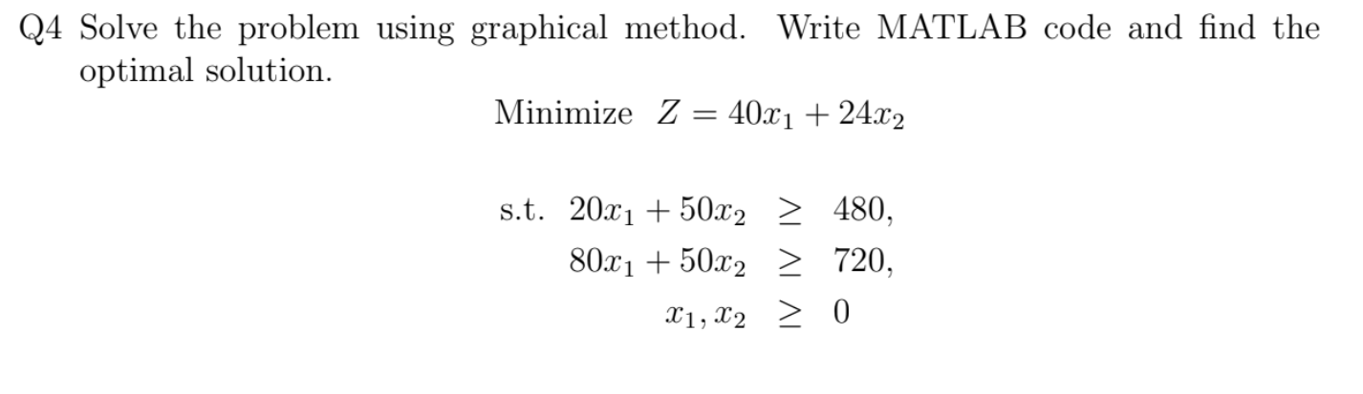

Code:

%% QUESTION 4: Graphical method to solve

% Min Z= 40x1+24x2

% 20x1+50x2>=480

% 80x1+50x2>=720

% x2>=0

% x1>=0

clc

clear all

format short

%INPUT PARAMETERS

c=[40,24]; %cost objective function

A=[20,50;80,50;0,1;1,0];

B=[480;720;0;0];

n=size(A,1);

x1=0:0.01:max(B);

for i=1:n-2 %we take n-2 since we are also taking x1=0 and x2=0 as they have no significance in our graph

y(i,:)=(B(i)-A(i,1)*x1)/A(i,2);

end

%DRAWING THE LINES

for i=1:n-2

y(i,:)=max(0,y(i,:));

plot(x1,y(i,:),'linewidth',4)

hold on

end

hold on

%FINDING THE POINT OF INTERSECTION

pt=[0;0];

for i=1:size(A,1)

A1=A(i,:);

B1=B(i,:);

for j=i+1:size(A,1)

A2=A(j,:);

B2=B(j,:);

A3=[A1;A2];

B3=[B1;B2];

%X3=inv(A3)*B3

X3=A3\B3;

if(X3>=0)%since the number of chairs can never be negative

pt= [pt X3];

end

end

end

X=pt';

X=unique(X,'rows')%solution

hold on

% KEEP ONLY FEASIBLE POINTS

x1=X(:,1);

x2=X(:,2);

for i=1:n-2

ind=find(A(i,:)*X'<B(i));

X(ind,:)=[];

end

% EVALUATE THE OBJECTIVE FUNCTION VALUE

obj_val=c*X';

[value, ind]=min(obj_val);

value;

X(ind,:);

Optimal=[X(ind,:) value]

Optimal_Coordinates=X(ind,:)

Optimal_Value=value

% Shaded feasible region

x=X(:,1);

y=X(:,2);

scatter(X(:,1),X(:,2),'*')

hold on

k=convhull(x,y);%the shaded region where a and y is satisfied

fill(x(k),y(k),'m')

% setting the axes

xlim([0 max(x)+1])

ylim([0 max(y)+1])

xlabel('x-axis')

ylabel('y-axis')

title('Feasible region of the linear programming problem')

legend('20x_1+50x_2\geq480','80x_1+50x_2\geq720', 'x_1,x_2\geq0')

Output:

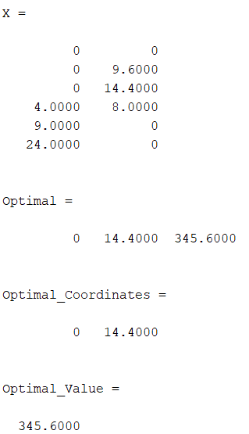

Graph:

